Chapter 13, Problem 65.

Calculate the average power dissipated by the 20-ohm resistor in Fig. 13.129.

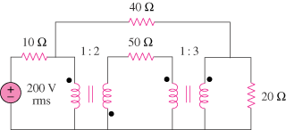

Figure 13.129
For Prob. 13.65.

